Module 5: Factors, Divisibility and Mathematical Loops
Question 6: 507. Perfect Number
Platform: LeetCode
Difficulty: Easy
Problem Link: https://leetcode.com/problems/perfect-number/
Problem Statement
A perfect number is a positive integer that is equal to the sum of its positive divisors, excluding the number itself.
A divisor of an integer x is an integer that can divide x evenly.
Given an integer n, return true if n is a perfect number, otherwise return false.
Examples
Example 1:
- Input: num = 28
- Output: true
- Explanation: 28 = 1 + 2 + 4 + 7 + 14.
Example 2:
- Input: num = 7
- Output: false
Constraints
- 1 <= num <= 10⁸
Code Screenshot
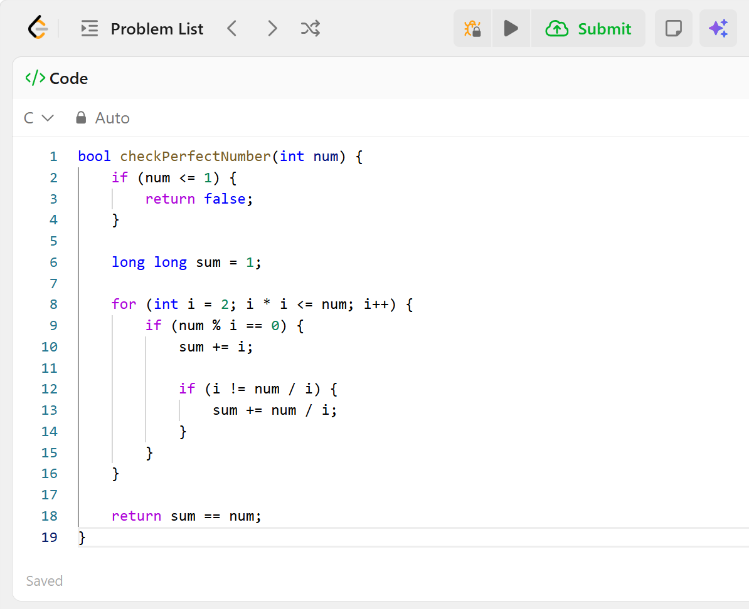Output Screenshot
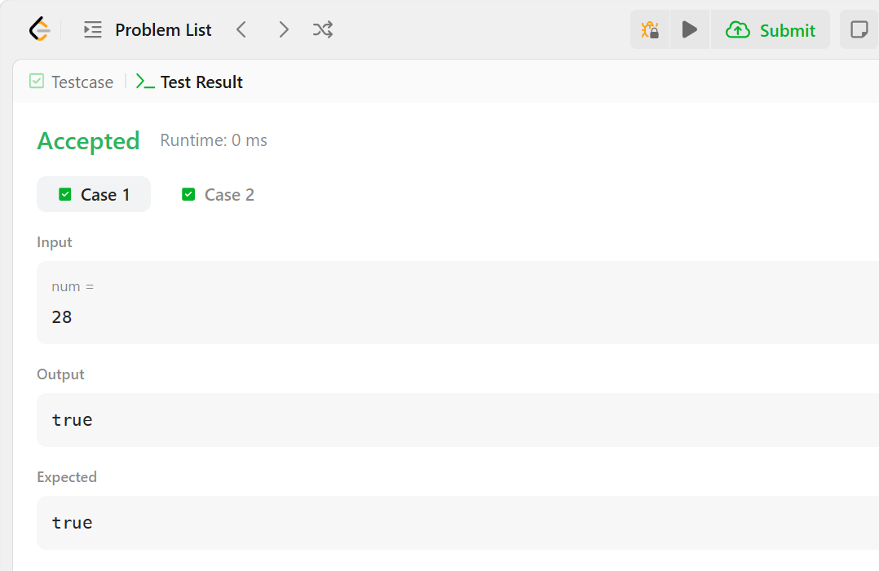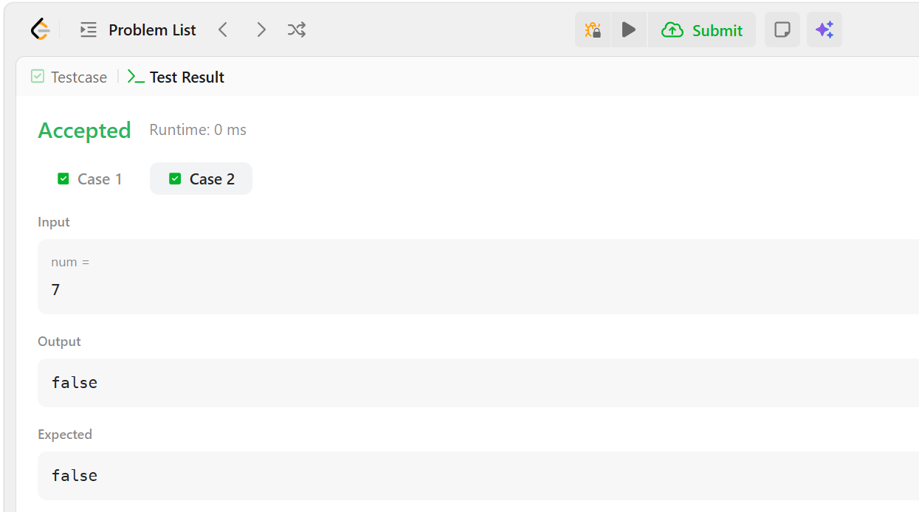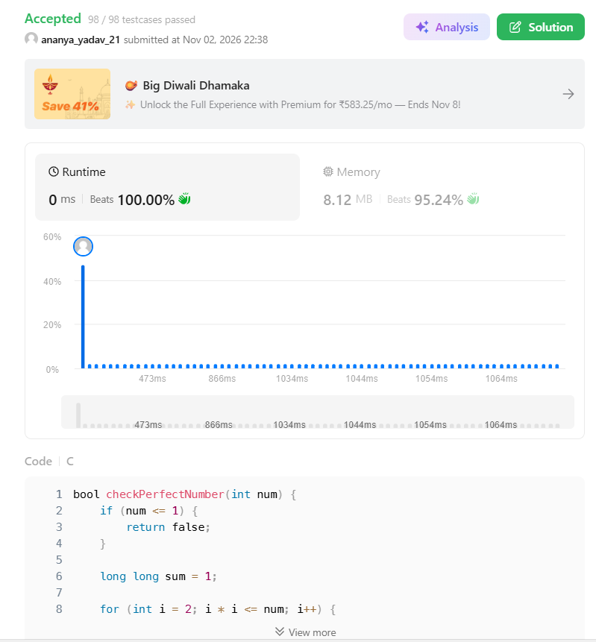
Result
The program checks whether the given number is a perfect number. Platform: LeetCode.

